A Guide to Herpes Simplex Virus-1
Kelli Robinson
Riverside Community College Dental Hygiene Program

Human herpes virus-1 is one of the leading causes of viral oral and perioral lesions (Seigal, 2002). Research by Seigal (2002) showed that human herpes virus-1 antibodies are found in up to 90% of Americans. Dental professionals should be knowledgeable on oral pathology in order to clinically make a differential diagnosis. The etiology, clinical manifestation, and treatment availabilities on the many common oral diseases is very beneficial to all registered dental hygienists. This will help with the spread of communicable diseases and ultimately bring better care to patients.
Epidemology
Prevelence
Human herpes virus-1, or herpes simplex-1 (HSV-1), is a very significant virus in the world today. HSV-1 is only one out of the eight different human herpes viruses’ known to cause infections in man. According to Little, Falace, Miller, and Rhodus (2008), the exact number of people infected is very hard to estimate because HSV-1 is not a reportable disease and some infections can be asymptomatic, however HSV-1 infections are extremely common and most adults have antibodies towards the virus. HSV-1 is also highly prevalent in immunocompromised patients, especially those who are HIV positive.
A recent study preformed by Kaufman et al. (2005) examined the frequency of shedding HSV-1 in tears and saliva from 50 different participants. The results showed 49 out of the 50 individuals shed HSV-1 DNA at some point during the study (Kaufman et al., 2005). ???Where to put this info and do I quote Kaufman twice???
Etiology
HSV-1 is a member of the Herpesviridae family (Miller et al., 2006). HSV-1 is known to cause the majority of viral lesions above the waste; the primary site being the oral mucosa, on the contrary herpes simplex-2 is the known virus to cause the majority of lesions below the waist (Little et al., 2008). However, Little et al. (2008) also said that either virus can be found on both regions of the body and can inoculate from one region to another.

Pathophysiology
Clinical Manifestations
Signs and Symptoms
Viral Laboratory Findings
Differential Diagnosis
Treatment Modalities
Primary Herpetic Gingivostomatitis
Recurrent Herpes Infection
Daily Treatment and preventive therapy

References
Finkelstein, M., Gallagher, G., & Kabani, S. P. (2002, May 13). Atlas of Oral Pathology. Retrieved April 14, 2008, from University of Iowa, College of Dentistry web site: http:// www.uiowa.edu/~oprm/AtlasWIN/AtlasFrame .html

Herpes. (n.d.). Retrieved April 14, 2008, from http://encarta.msn.com/ encyclopedia_761577697 Herpes.html#s2

Ipsen, O. A. & Phelan, J. A. (2004). Oral pathology for the dental hygienist (4th ed.). Missouri: Saunders.
Kaufman, H. E., Azcuy, A. M., Varnell, E. D., Sloop, G. D., Thompson, H. W., & Hill J. M. (2005). HSV-1 DNA in tears and saliva of normal adults. Investigative Opthamalogy and Visual Science, 46(1), 241-247.
Little, J. W., Falace, D. A., Miller, C. S., & Rhodus, N. L. (2008). Dental management of the medically compromised patient (7th ed.). Missouri: Elsevier Mosby.
Miller, C. S., Berger, J. R., Mootoor, Y., Avdiushko, S. A., Zhu, H., & Kryscio, R. J. (2006). High prevelence of multiple human herpesviruses in saliva from human immunodeficiency virus-ifected persons in the era of highly active antiretroviral therapy. Journal of Clinical Microbiology, 44(7), 2409-2415.
Miller, C. S., Cunningham, L. L., Lindroth, J. E., & Avdiushko, S. A. (2004). The efficacy of valacyclovir in preventing recurrent herpes simplex virus infections associated with dental procedures. The Journal of the American Dental Association, 135(9), 1311-1318.
Raborn, G. W., Martel, A. Y., Lassonde, M., Lewis, M. A., Boon, R., & Spruance, S. L. (2002). Effective treatment of herpes simplex labialis with penciclovir cream: Combined results of two trials. The Journal of the American Dental Association, 133, 303-309.
Siegel, M. A. (2002). Diagnosis and management of recurrent herpes simplex infections. The Journal of the American Dental Association, 133, 1245-1249.
Vrioni, G., Kalogeropoulos, C., Gartzonika, C., Priavali, E., & Levidiotou, S. (2007). Usefulness of Herpes Consensus PCR methodology to routine diagnostic testion for herpesviruses infections in clinical specimens. Virology Journal, 4, 59.

????
Raborn, G. W. & Grace, M. G. (2003). Recurrent herpes simplex labialis: Selected therapeutic options. Journal of the Canadian Dental Association, 69(8), 498-503.
Tillias, S.I. & McDowell, J. (2002). Differential diagnosis: Is it herpes or aphthous? The Journal of Contemporary Dental Practice, 3(1), 1-15.

Appendix A
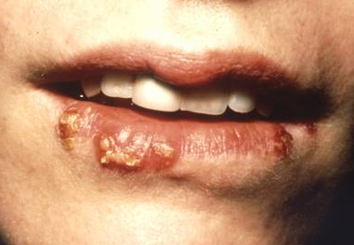
Note. From “Herpes,” (n.d.) Retrieved April 14, 2008, from http://encarta.msn.com. Copyright 2007 by Microsoft Corporation. Reprinted with permission.

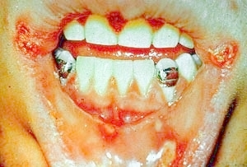
Appendix B

Note. From “Atlas of Oral Pathology,” by M. Finkelstein, G. Gallagher, & S. P. Kabani, (2002). Retrieved April 14, 2008, from University of Iowa, College of Dentistry web site: http:// www.uiowa.edu/~oprm. Copyright 2002 by the University of Iowa. Reprinted with permission.

Appendix C
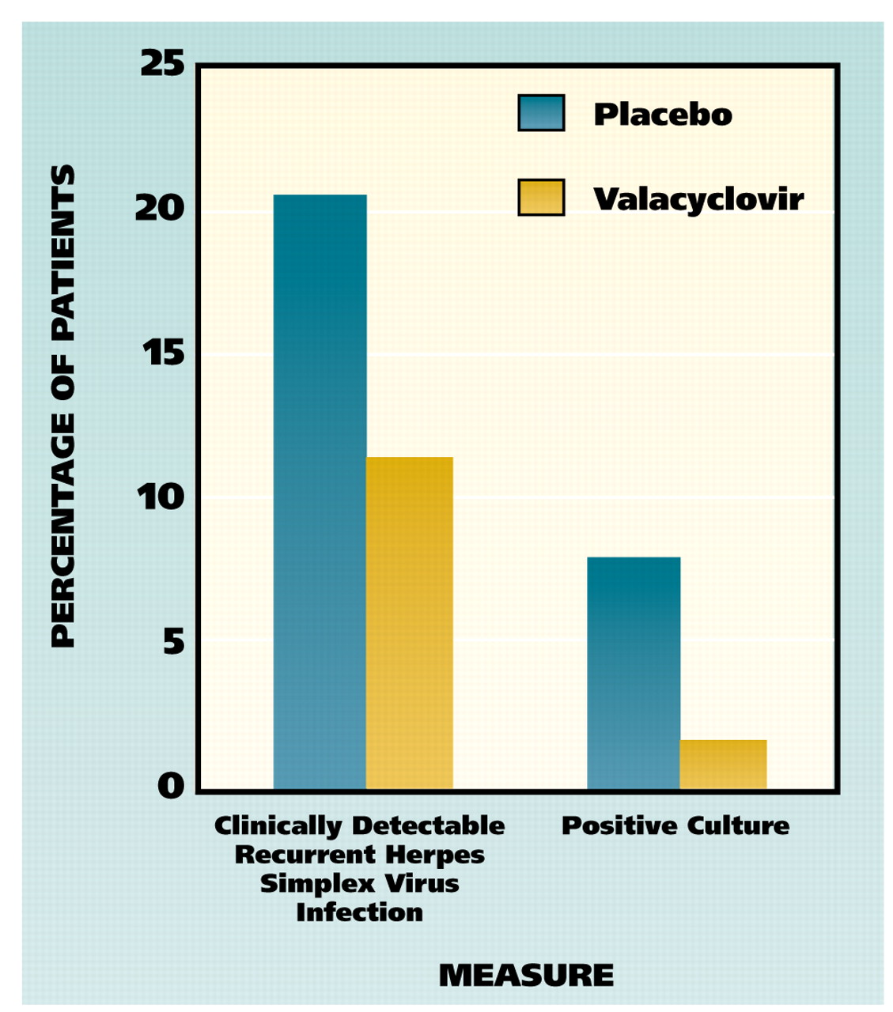

Note. From “The efficacy of valacyclovir in preventing recurrent herpes simplex virus infections associated with dental procedures,” by C. S. Miller, L. L. Cunningham, J. E. Lindroth, & S. A. Avdiushko, 2004, The Journal of the American Dental Association, 135(9), p. 1314. Copyright 2004 by American Dental Association. Reprinted with permission

